SAARTHI  
A Healthcare Ecosystem



# Team Leader: Utkarsh Anuse, 9404915625, utkarsh.anuse20@vit.edu

Team Members

1. Akshay Aadarsh
2. Anish Parkhe
3. Anish Patil
4. Utkarsh Anuse

# Problem Statement :

We aim to address the issue of limited access to accurate and reliable vital sign monitoring for patients who are in need of continuous monitoring outside of a clinical setting by designing and developing a portable, non-invasive device that accurately measures and records the BP, SpO2, temperature, and ECG values of a user or patient and provides real-time monitoring and analysis of the data.

# Solution(Website,Mobile App,Hardware,IoT,Others):

* Website
* IOT
* Hardware

(All three Inclusive)

# 

# Documentation

Explain what you accomplished on this day

1. We have finalized all the requirements for developing our healthcare kit which calculates the values of BP, SpO2, Temperature and ECG.
2. We have started creating the 3D design of how our system’s input, output and displays will be placed.
3. Here is the initial layout of our system:

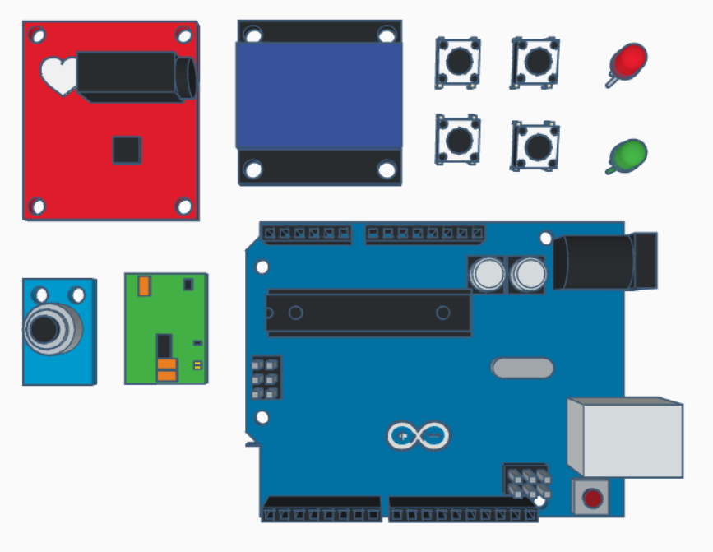

1. Architecture Design

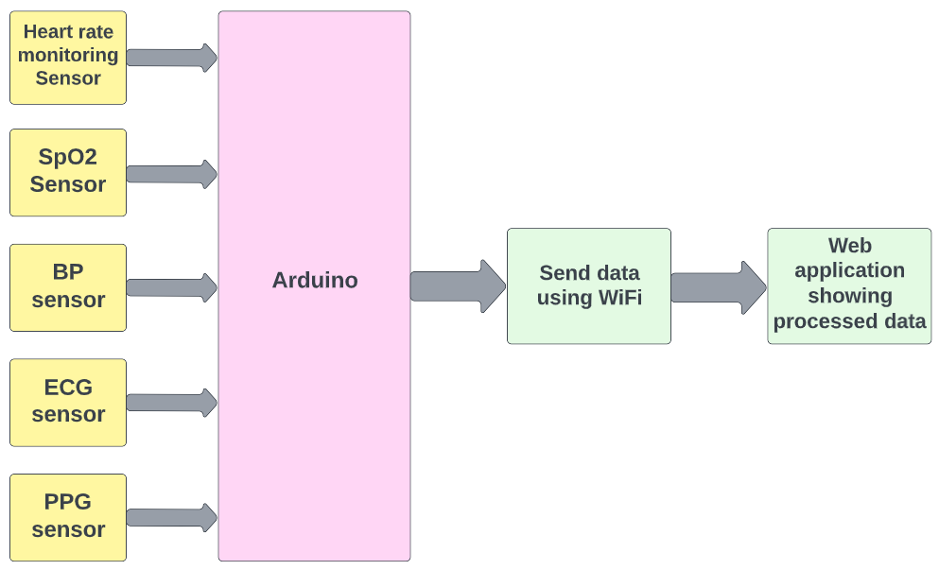

Explain what you accomplished on this day

1. On day 2 we made a 3D model corresponding to the problem statement given earlier.

Here are some of the images of the expected model from various angle

|  |  |
| --- | --- |
|  |  |

|  |  |
| --- | --- |
|  |  |
|  |  |

We have modeled a patient friendly case to house all the equipment necessary. This case is small and compact. This case is fitted with a user interface display and four buttons (up, down, select, back) to navigate between different actions. Two indicator leds are also fitted on the case, red for indicating that the device is powered on and green for selected action is taking place or finished. We have selected HDPE ( High-density polyethylene) for manufacturing this case, HDPE being non-porous and because of its toughness makes it an ideal candidate to make the protective shell of medical devices.

Explain what you accomplished on this day

1. We first connected all the sensors and our microcontroller Arduino to get the desired output. Below given is its original circuit diagram.

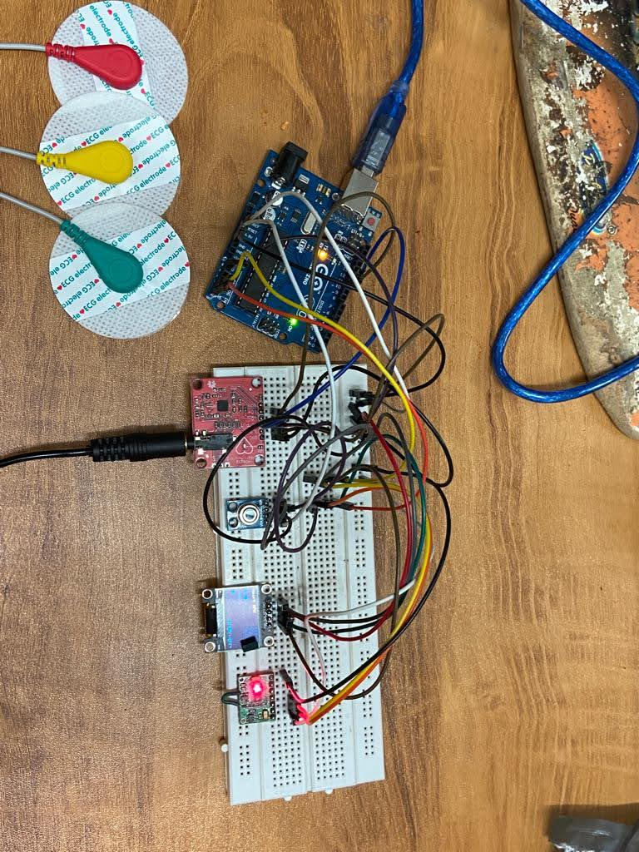

**Working Steps:**

1. The patient would place his/her finger on the sensing unit.
2. The sensors would sense the heartbeat and the vitals with body temperature.
3. ECG and BP sensors will be situated on the chest and arm.
4. The sensed data rates are sent in the form of signals.
5. The Arduino processes the same data and would transmit the data to the Wi-Fi module.
6. The Wi-Fi module would then retransmit the data to the web application.
7. Processing Data through Arduino UNO.

Here are some ss of Output observed

2. ECG graph (Female)

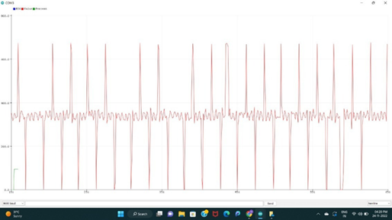

3. ECG graph (Male)

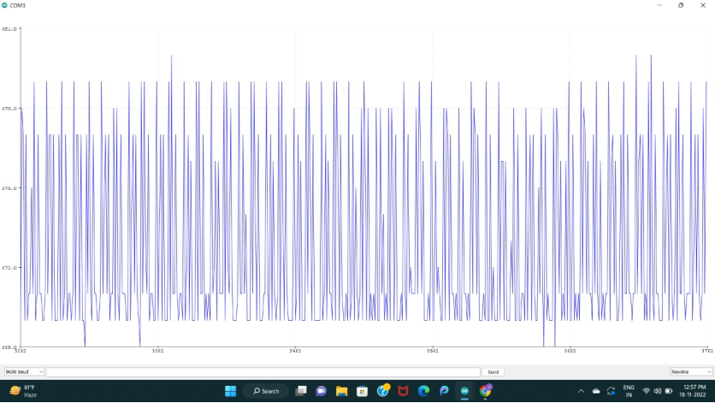

4. Temperature Values

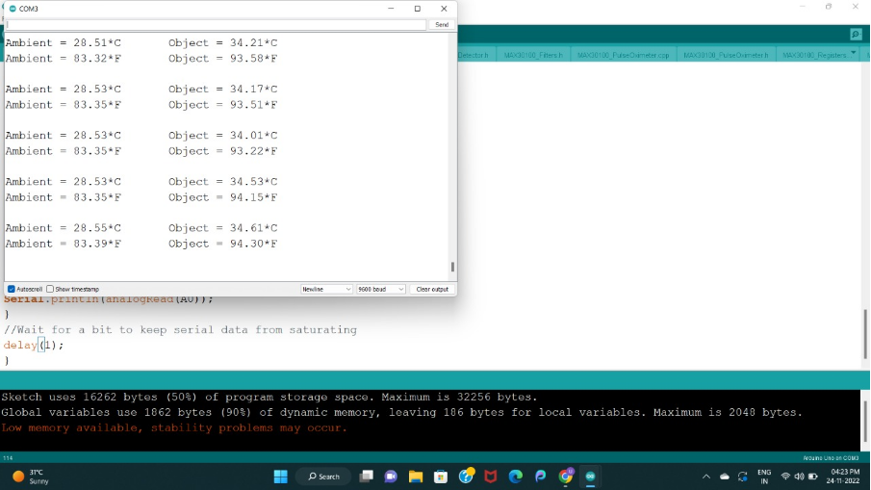

5. BPM and SPo2 values

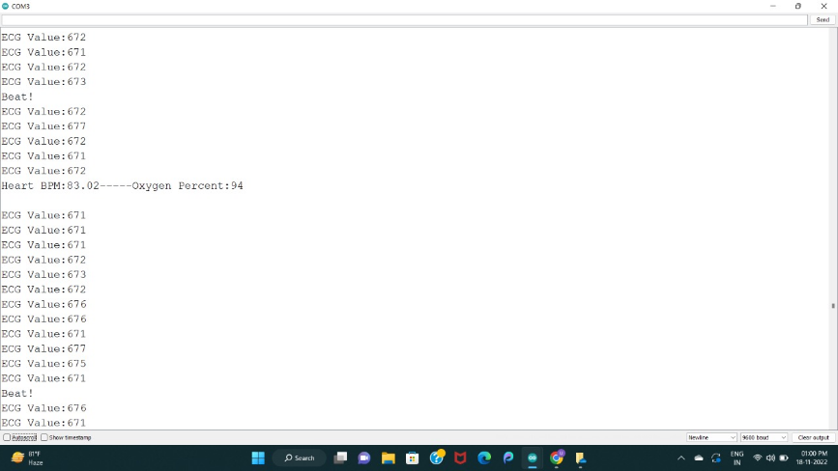

6.Electrode Positioning

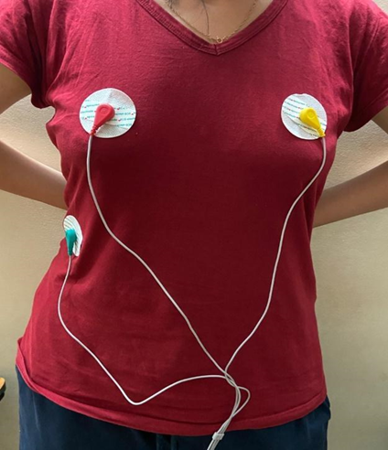

Link to PPT:

Link to 3 Min Video:

Explain what you accomplished on this day

1. Calibrated our model by comparing the output values obtained by the model vs the values obtained from the traditional method.

|  |  |
| --- | --- |
|  |  |

Here as expected we can see the diastolic blood pressure value in traditional sphygmomanometer comes out to be 84 whereas the value obtained from the proposed model by just placing the finger on the sensor is 84.06 which accurately matches with the traditional one.

|  |  |
| --- | --- |
|  |  |

On the left is the normal pulse oximeter, when tested it showed 95% oxygen level. After using the traditional method the user switched to our proposed model where it is again observed to be 95% in front of the Oxygen percent shown in the right image.

**Analysis of ECG machines:**

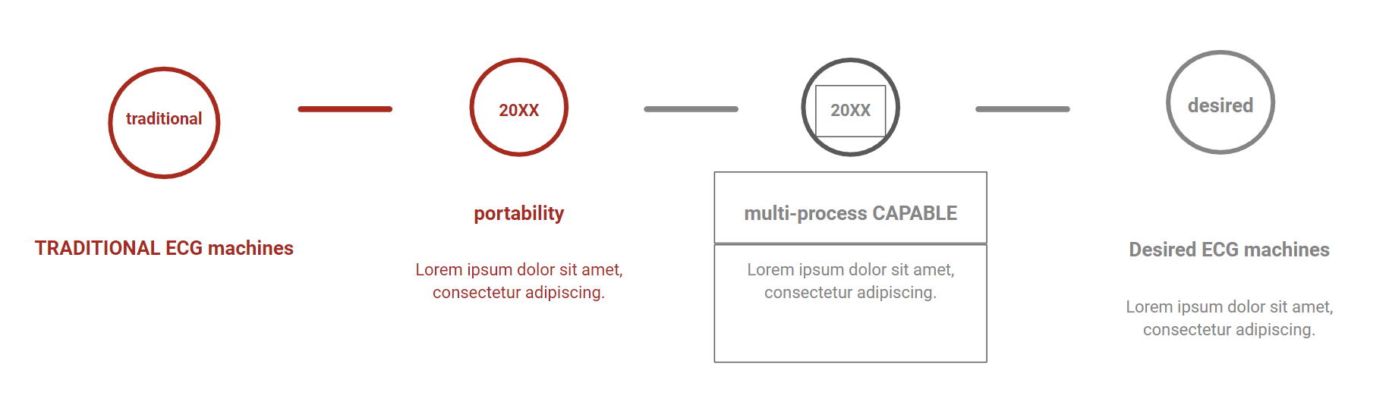

**Website:**



